**1A01**

**Instructions for Preparation of Abstract**

**Second Line of Title if needed**

○Miyako Yoshida1, Hanako Osaka 2, Taro Yagami 3

*1 Graduate School of Science, Kyoto University, Japan*

*2 Graduate School of Engineering, Osaka University, Japan*

*3 Faculty of Science and Technology, Keio University, Japan*

**[Abstract]** Abstract in English (ca. 150 words).

**[Introduction]** This is a sample abstract for the Annual Meeting of Japan Society for Molecular Science. Please overwrite this template and submit in PDF format with the file size less than 5 Mb.

1. The manuscript should fit on two A4 pages without the page number, within top and bottom margins of 25 mm and side margins of 25 mm.
2. Put the manuscript number at the top in 14 pt **boldface** Helvetica font. The title should be typed in 14 pt **boldface** Times New Roman font and centered. After 12 pt 0.5 spacing the names of the authors (12 pt), *affiliations* and *addresses* (12 pt, *Italic*) are typed. After 12 pt vertical spacing the Abstract is typed.
3. Abstract in ca. 150 words should be typed using Times New Roman font with 12 pt size. After 12 pt vertical spacing the body text is typed in Times New Roman font with 12 pt size.
4. Figures will be shown in full color. Give each figure with a separate caption (10 pt). Pay close attention to the file sizes to avoid producing an oversized final PDF abstract file.
5. References in the text should be given by numbers in square brackets [..]. The list of references in 10 pt font follows the last line of the text.
6. The recommended font sizes, as used in the Word template, are listed in Table 1.

**Table 1**. Font sizes to be used in the abstract.

|  |  |  |  |  |  |
| --- | --- | --- | --- | --- | --- |
|  | Title | Body | Captions | Refs. | Tables |
| Size | 14 pt | 12 pt | 10 pt | 10 pt | 11 pt |

**[Methods]**

**[Results and Discussion]**

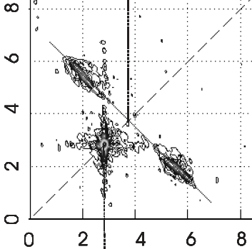

**Fig. 1.** Experimental Data.

**[References]**

[1] T. Fukuoka *et al*. *Chem. Phys. Lett.* **123**, 456 (2018).

[2] H. Sendai and T. Fukuoka, “Theory of X parameter”, (John Wiley, New York, 2018), pp. 12-24.

[3] Fukuoka, Sendai, and Hyogo, Abstract of the 2nd Annual Meeting of Japan Society for Molecular Science, 1P001 (2008).